**CS648   
Assignment 2**

In this assignment, your job will be to create a four-page website for Vecta Corp. The website will include web pages for Home, About Us, Solutions, and Contact Us. Each page should look like the ones outlined within this document.

**General items you will need to account for**

* The starting index.html page has already been created for you. Within the page I have added some inline styles to the <body> tag to set the margin and default width of the page. Don’t touch this. This code will essentially center your design within the page. You will add your structure within the <body> element.
* You will create three additional web pages based on the index.html file. They will include an about page (aboutus.html), a solutions page (solutions.html), and a contact us page (contactus.html).
* Each page will feature a navigation menu. Each menu item should link to its respective web page. The navigation menu will be made up of four individual images all located within the images folder.
* Pay close attention to the formatting on each page. I want you to duplicate the semantic structure and semantic text-level markup as you see it. If I have an item bolded, and you fail to bold it, I will deduct points. If I have an item italicized and you fail to italicize it, I will deduct points, and so on.
* All headings should use the <h2> element.

**Specific items you will need to account for per page**

* On the Home page, the Module Media link should point to http://www.modulemedia.com.

**Home Page**

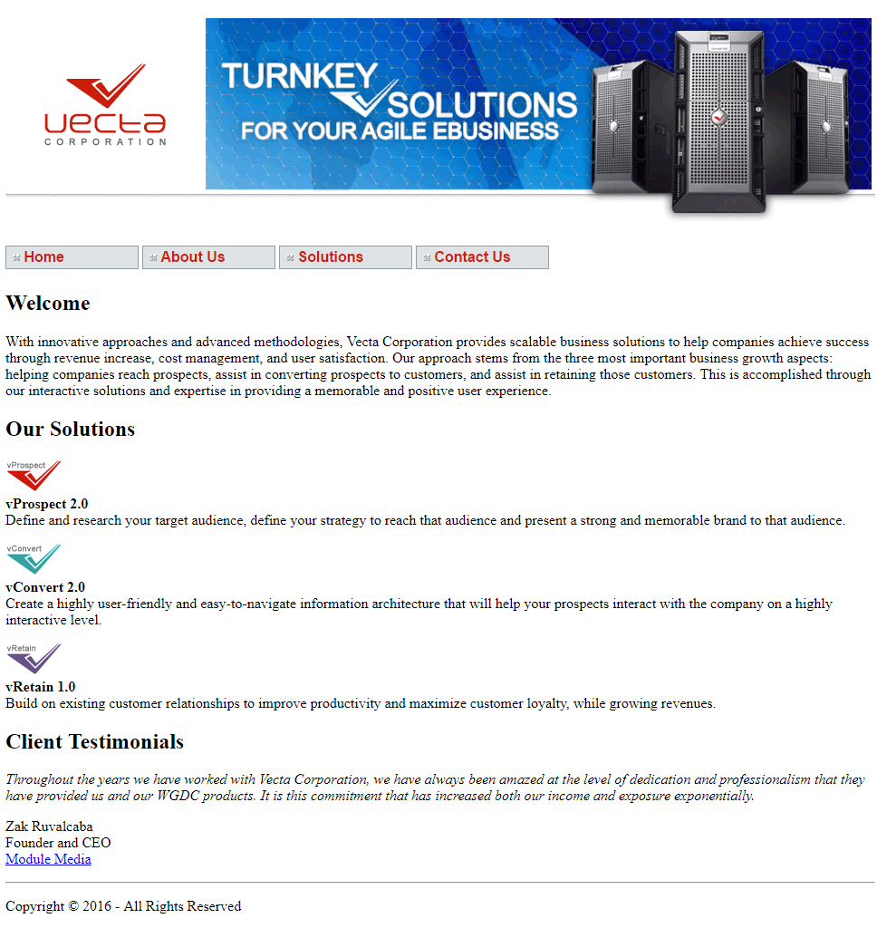

**About Us Page**

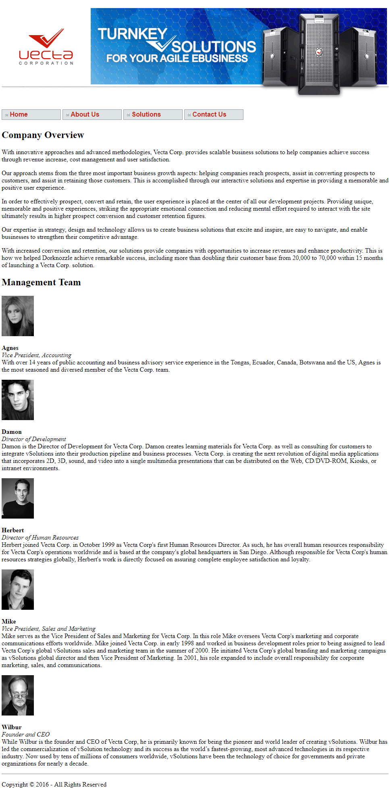

**Solutions Page**

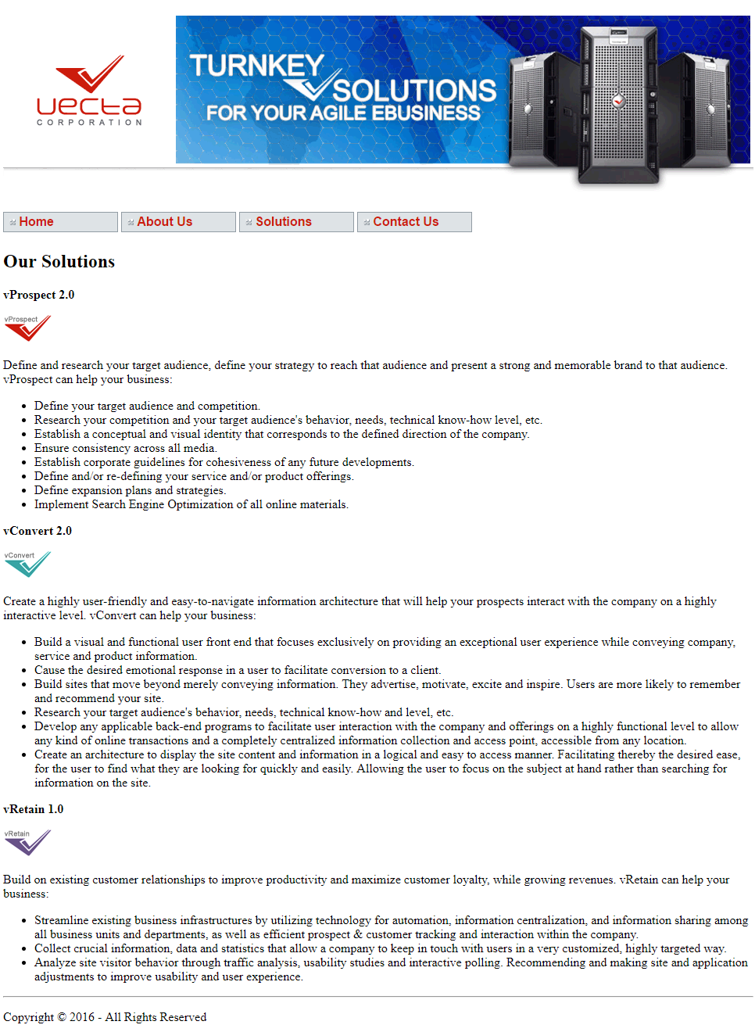

**Contact Us Page**

